[[](http://www.199it.com/wp-content/uploads/2019/04/2019%E4%B8%AD%E5%9B%BD%E8%83%BD%E6%BA%90%E5%8C%96%E5%B7%A5%E4%BA%A7%E4%B8%9A%E5%8F%91%E5%B1%95%E6%8A%A5%E5%91%8A4_000001.jpg)](http://www.199it.com/wp-content/uploads/2019/04/2019%E4%B8%AD%E5%9B%BD%E8%83%BD%E6%BA%90%E5%8C%96%E5%B7%A5%E4%BA%A7%E4%B8%9A%E5%8F%91%E5%B1%95%E6%8A%A5%E5%91%8A4_000001.jpg)[](http://www.199it.com/wp-content/uploads/2019/04/2019%E4%B8%AD%E5%9B%BD%E8%83%BD%E6%BA%90%E5%8C%96%E5%B7%A5%E4%BA%A7%E4%B8%9A%E5%8F%91%E5%B1%95%E6%8A%A5%E5%91%8A4_000002.jpg)[](http://www.199it.com/wp-content/uploads/2019/04/2019%E4%B8%AD%E5%9B%BD%E8%83%BD%E6%BA%90%E5%8C%96%E5%B7%A5%E4%BA%A7%E4%B8%9A%E5%8F%91%E5%B1%95%E6%8A%A5%E5%91%8A4_000003.jpg)[](http://www.199it.com/wp-content/uploads/2019/04/2019%E4%B8%AD%E5%9B%BD%E8%83%BD%E6%BA%90%E5%8C%96%E5%B7%A5%E4%BA%A7%E4%B8%9A%E5%8F%91%E5%B1%95%E6%8A%A5%E5%91%8A4_000004.jpg)[](http://www.199it.com/wp-content/uploads/2019/04/2019%E4%B8%AD%E5%9B%BD%E8%83%BD%E6%BA%90%E5%8C%96%E5%B7%A5%E4%BA%A7%E4%B8%9A%E5%8F%91%E5%B1%95%E6%8A%A5%E5%91%8A4_000005.jpg)[](http://www.199it.com/wp-content/uploads/2019/04/2019%E4%B8%AD%E5%9B%BD%E8%83%BD%E6%BA%90%E5%8C%96%E5%B7%A5%E4%BA%A7%E4%B8%9A%E5%8F%91%E5%B1%95%E6%8A%A5%E5%91%8A4_000006.jpg)[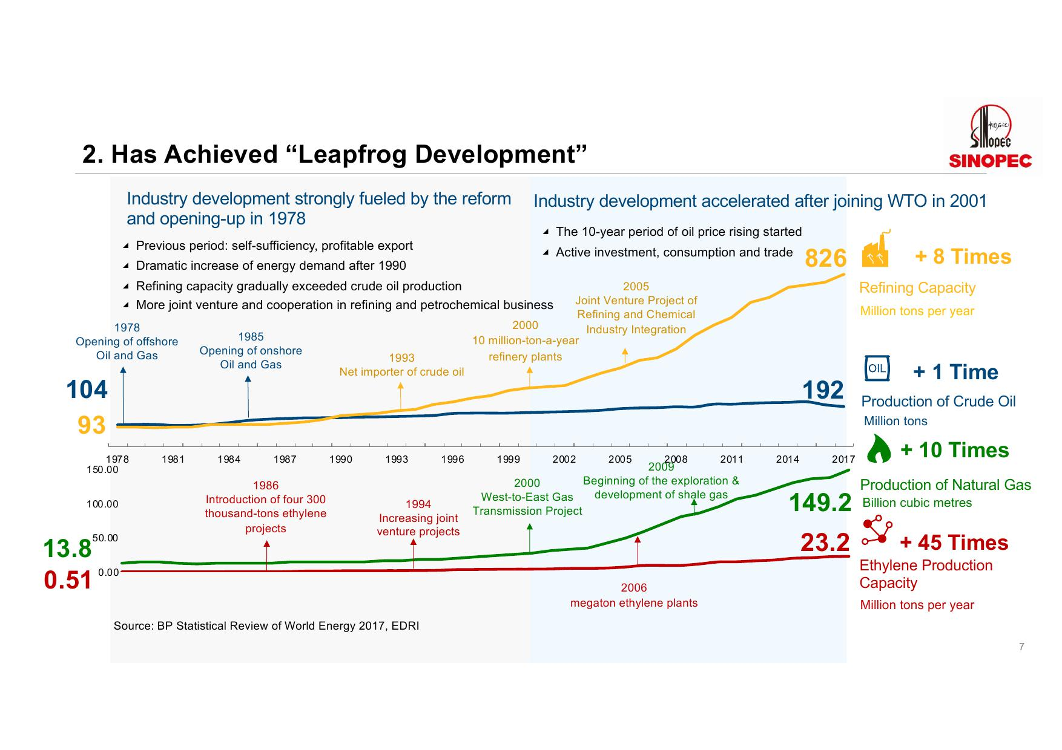](http://www.199it.com/wp-content/uploads/2019/04/2019%E4%B8%AD%E5%9B%BD%E8%83%BD%E6%BA%90%E5%8C%96%E5%B7%A5%E4%BA%A7%E4%B8%9A%E5%8F%91%E5%B1%95%E6%8A%A5%E5%91%8A4_000007.jpg)[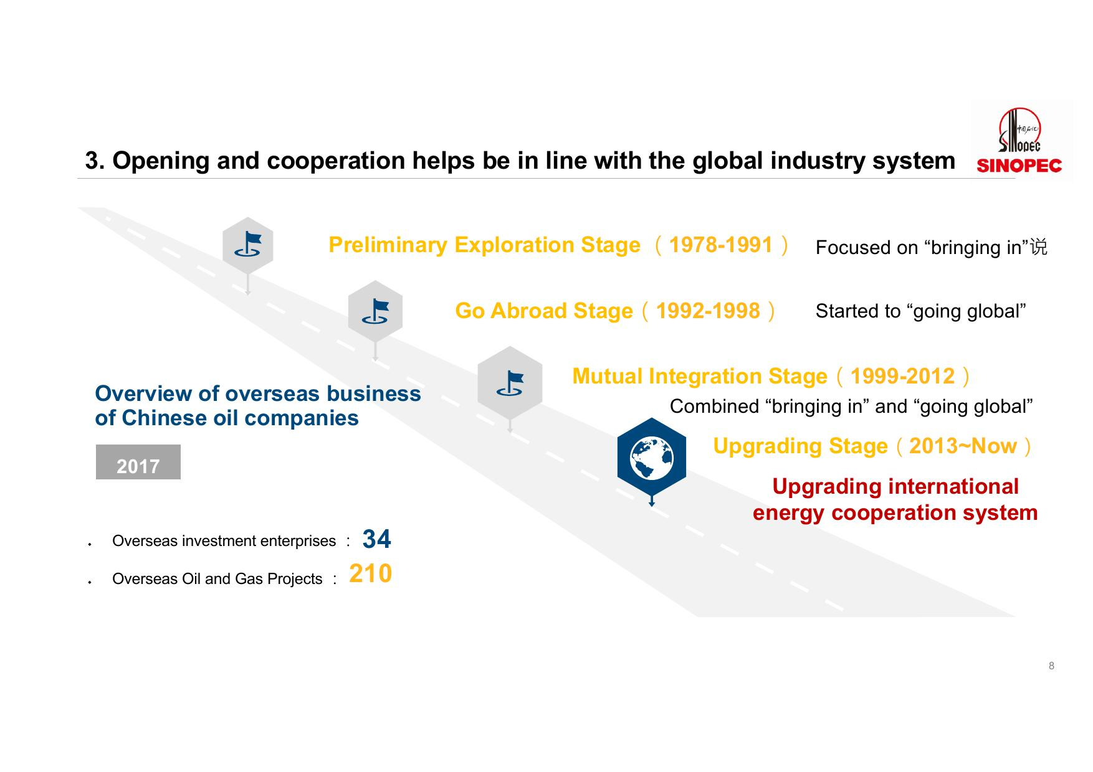](http://www.199it.com/wp-content/uploads/2019/04/2019%E4%B8%AD%E5%9B%BD%E8%83%BD%E6%BA%90%E5%8C%96%E5%B7%A5%E4%BA%A7%E4%B8%9A%E5%8F%91%E5%B1%95%E6%8A%A5%E5%91%8A4_000008.jpg)[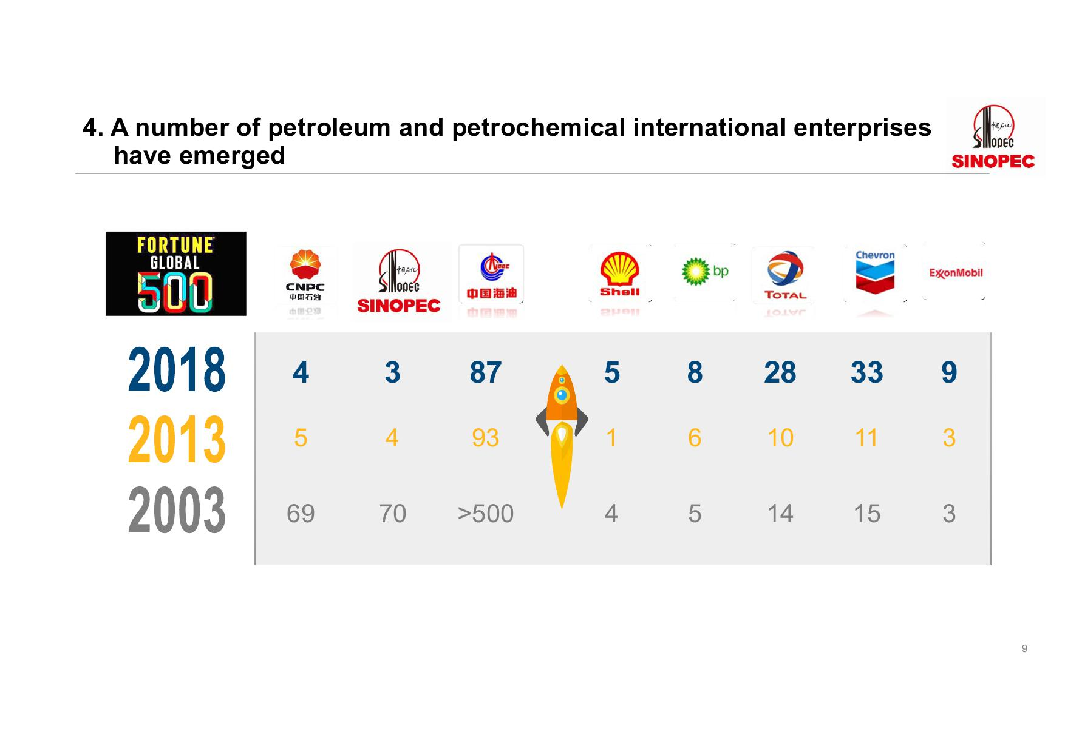](http://www.199it.com/wp-content/uploads/2019/04/2019%E4%B8%AD%E5%9B%BD%E8%83%BD%E6%BA%90%E5%8C%96%E5%B7%A5%E4%BA%A7%E4%B8%9A%E5%8F%91%E5%B1%95%E6%8A%A5%E5%91%8A4_000009.jpg)[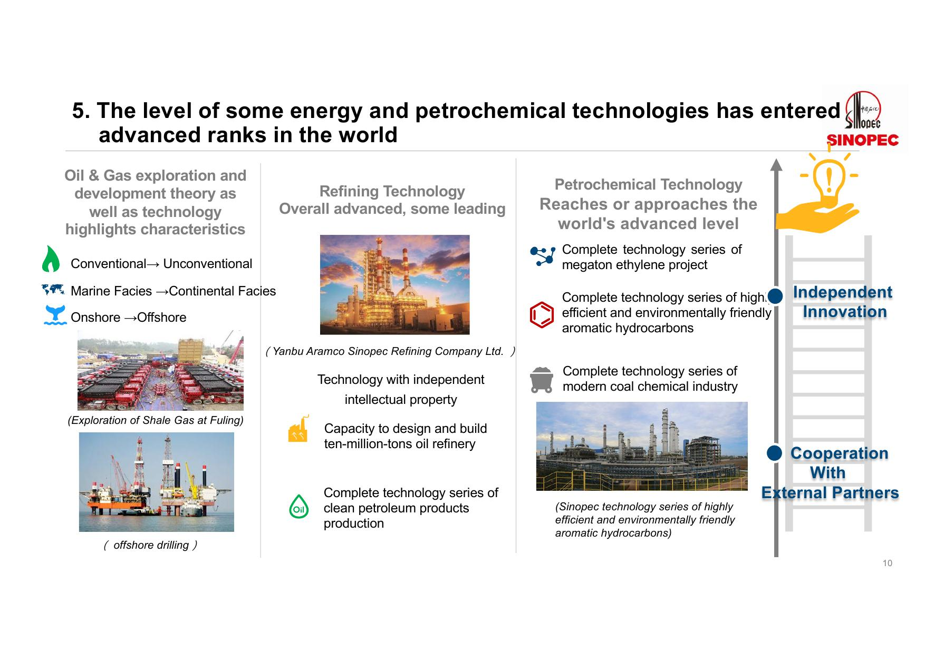](http://www.199it.com/wp-content/uploads/2019/04/2019%E4%B8%AD%E5%9B%BD%E8%83%BD%E6%BA%90%E5%8C%96%E5%B7%A5%E4%BA%A7%E4%B8%9A%E5%8F%91%E5%B1%95%E6%8A%A5%E5%91%8A4_000010.jpg)[](http://www.199it.com/wp-content/uploads/2019/04/2019%E4%B8%AD%E5%9B%BD%E8%83%BD%E6%BA%90%E5%8C%96%E5%B7%A5%E4%BA%A7%E4%B8%9A%E5%8F%91%E5%B1%95%E6%8A%A5%E5%91%8A4_000011.jpg)[](http://www.199it.com/wp-content/uploads/2019/04/2019%E4%B8%AD%E5%9B%BD%E8%83%BD%E6%BA%90%E5%8C%96%E5%B7%A5%E4%BA%A7%E4%B8%9A%E5%8F%91%E5%B1%95%E6%8A%A5%E5%91%8A4_000012.jpg)[](http://www.199it.com/wp-content/uploads/2019/04/2019%E4%B8%AD%E5%9B%BD%E8%83%BD%E6%BA%90%E5%8C%96%E5%B7%A5%E4%BA%A7%E4%B8%9A%E5%8F%91%E5%B1%95%E6%8A%A5%E5%91%8A4_000013.jpg)[](http://www.199it.com/wp-content/uploads/2019/04/2019%E4%B8%AD%E5%9B%BD%E8%83%BD%E6%BA%90%E5%8C%96%E5%B7%A5%E4%BA%A7%E4%B8%9A%E5%8F%91%E5%B1%95%E6%8A%A5%E5%91%8A4_000014.jpg)[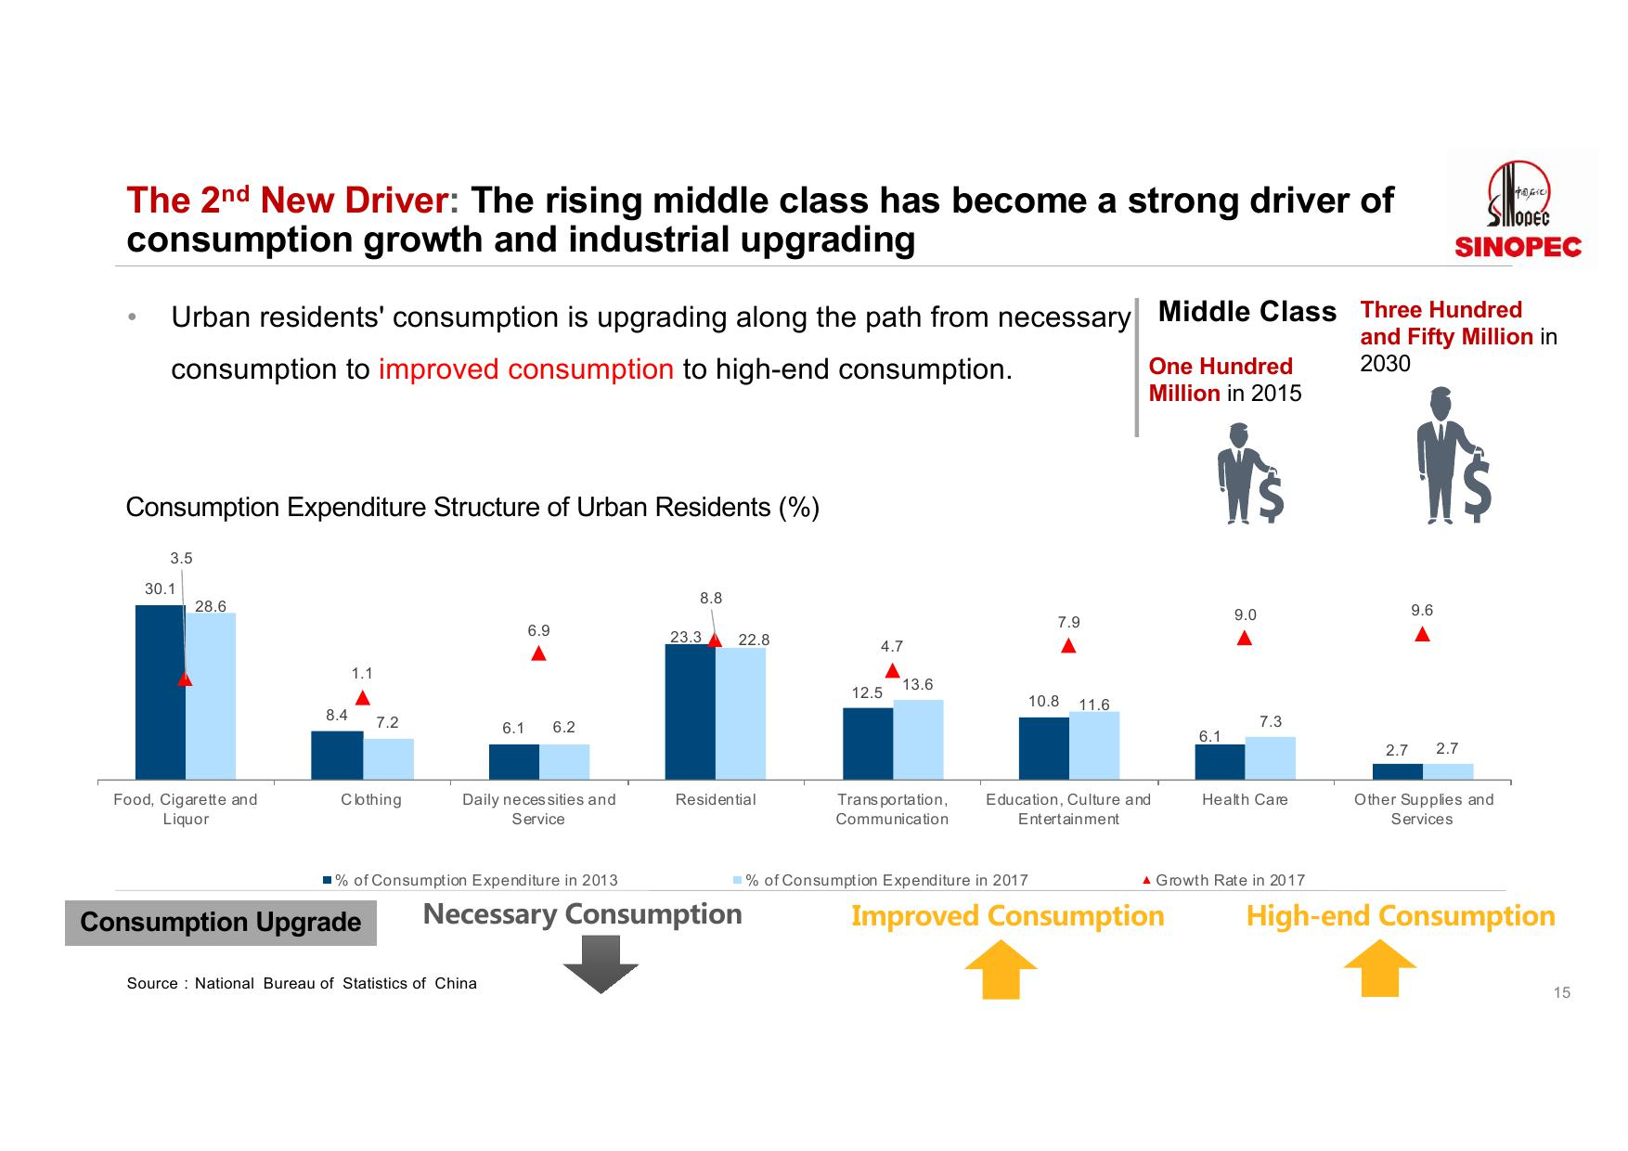](http://www.199it.com/wp-content/uploads/2019/04/2019%E4%B8%AD%E5%9B%BD%E8%83%BD%E6%BA%90%E5%8C%96%E5%B7%A5%E4%BA%A7%E4%B8%9A%E5%8F%91%E5%B1%95%E6%8A%A5%E5%91%8A4_000015.jpg)[](http://www.199it.com/wp-content/uploads/2019/04/2019%E4%B8%AD%E5%9B%BD%E8%83%BD%E6%BA%90%E5%8C%96%E5%B7%A5%E4%BA%A7%E4%B8%9A%E5%8F%91%E5%B1%95%E6%8A%A5%E5%91%8A4_000016.jpg)[](http://www.199it.com/wp-content/uploads/2019/04/2019%E4%B8%AD%E5%9B%BD%E8%83%BD%E6%BA%90%E5%8C%96%E5%B7%A5%E4%BA%A7%E4%B8%9A%E5%8F%91%E5%B1%95%E6%8A%A5%E5%91%8A4_000017.jpg)[](http://www.199it.com/wp-content/uploads/2019/04/2019%E4%B8%AD%E5%9B%BD%E8%83%BD%E6%BA%90%E5%8C%96%E5%B7%A5%E4%BA%A7%E4%B8%9A%E5%8F%91%E5%B1%95%E6%8A%A5%E5%91%8A4_000018.jpg)[](http://www.199it.com/wp-content/uploads/2019/04/2019%E4%B8%AD%E5%9B%BD%E8%83%BD%E6%BA%90%E5%8C%96%E5%B7%A5%E4%BA%A7%E4%B8%9A%E5%8F%91%E5%B1%95%E6%8A%A5%E5%91%8A4_000019.jpg)[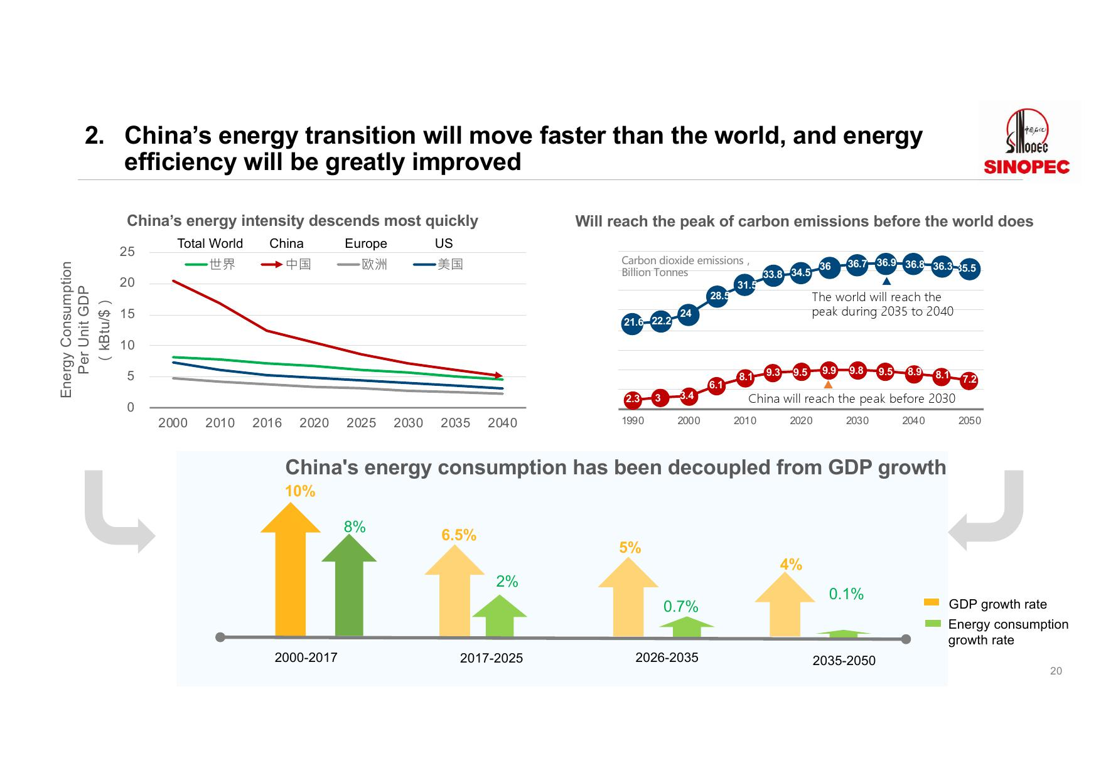](http://www.199it.com/wp-content/uploads/2019/04/2019%E4%B8%AD%E5%9B%BD%E8%83%BD%E6%BA%90%E5%8C%96%E5%B7%A5%E4%BA%A7%E4%B8%9A%E5%8F%91%E5%B1%95%E6%8A%A5%E5%91%8A4_000020.jpg)[](http://www.199it.com/wp-content/uploads/2019/04/2019%E4%B8%AD%E5%9B%BD%E8%83%BD%E6%BA%90%E5%8C%96%E5%B7%A5%E4%BA%A7%E4%B8%9A%E5%8F%91%E5%B1%95%E6%8A%A5%E5%91%8A4_000021.jpg)[](http://www.199it.com/wp-content/uploads/2019/04/2019%E4%B8%AD%E5%9B%BD%E8%83%BD%E6%BA%90%E5%8C%96%E5%B7%A5%E4%BA%A7%E4%B8%9A%E5%8F%91%E5%B1%95%E6%8A%A5%E5%91%8A4_000022.jpg)[](http://www.199it.com/wp-content/uploads/2019/04/2019%E4%B8%AD%E5%9B%BD%E8%83%BD%E6%BA%90%E5%8C%96%E5%B7%A5%E4%BA%A7%E4%B8%9A%E5%8F%91%E5%B1%95%E6%8A%A5%E5%91%8A4_000023.jpg)[](http://www.199it.com/wp-content/uploads/2019/04/2019%E4%B8%AD%E5%9B%BD%E8%83%BD%E6%BA%90%E5%8C%96%E5%B7%A5%E4%BA%A7%E4%B8%9A%E5%8F%91%E5%B1%95%E6%8A%A5%E5%91%8A4_000024.jpg)[](http://www.199it.com/wp-content/uploads/2019/04/2019%E4%B8%AD%E5%9B%BD%E8%83%BD%E6%BA%90%E5%8C%96%E5%B7%A5%E4%BA%A7%E4%B8%9A%E5%8F%91%E5%B1%95%E6%8A%A5%E5%91%8A4_000025.jpg)[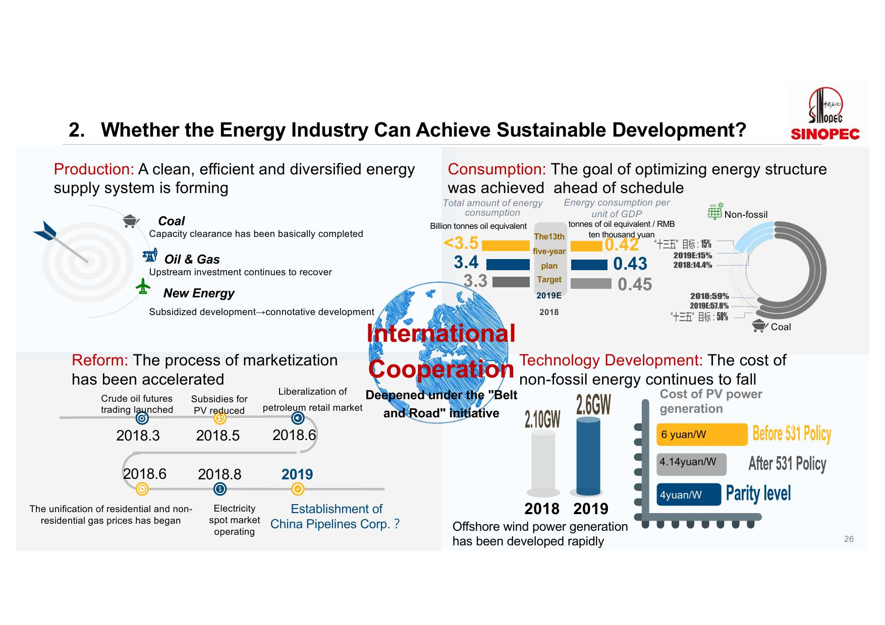](http://www.199it.com/wp-content/uploads/2019/04/2019%E4%B8%AD%E5%9B%BD%E8%83%BD%E6%BA%90%E5%8C%96%E5%B7%A5%E4%BA%A7%E4%B8%9A%E5%8F%91%E5%B1%95%E6%8A%A5%E5%91%8A4_000026.jpg)[](http://www.199it.com/wp-content/uploads/2019/04/2019%E4%B8%AD%E5%9B%BD%E8%83%BD%E6%BA%90%E5%8C%96%E5%B7%A5%E4%BA%A7%E4%B8%9A%E5%8F%91%E5%B1%95%E6%8A%A5%E5%91%8A4_000027.jpg)[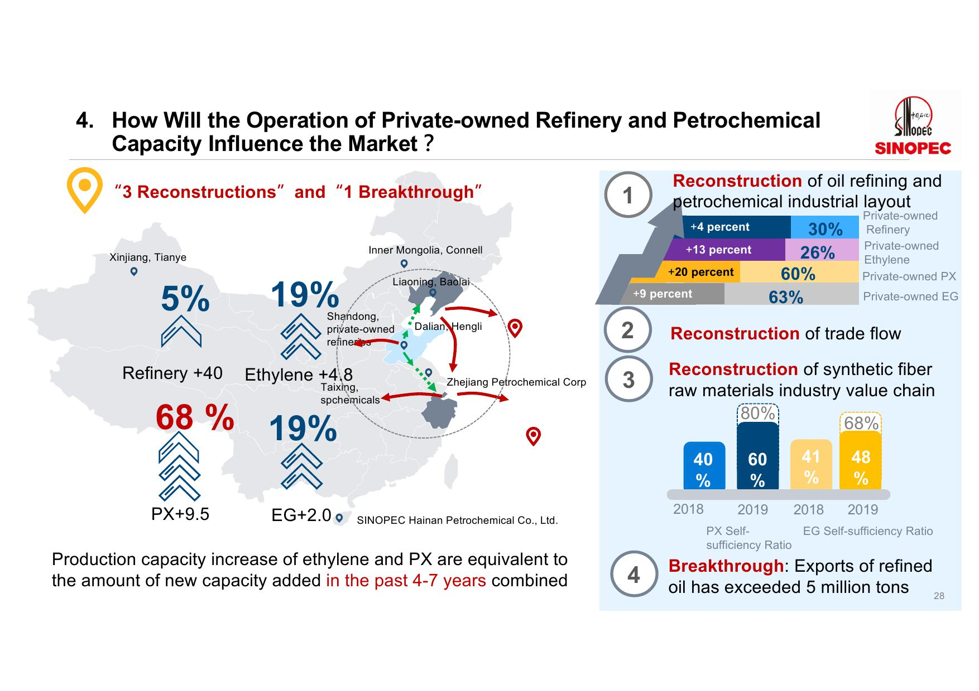](http://www.199it.com/wp-content/uploads/2019/04/2019%E4%B8%AD%E5%9B%BD%E8%83%BD%E6%BA%90%E5%8C%96%E5%B7%A5%E4%BA%A7%E4%B8%9A%E5%8F%91%E5%B1%95%E6%8A%A5%E5%91%8A4_000028.jpg)[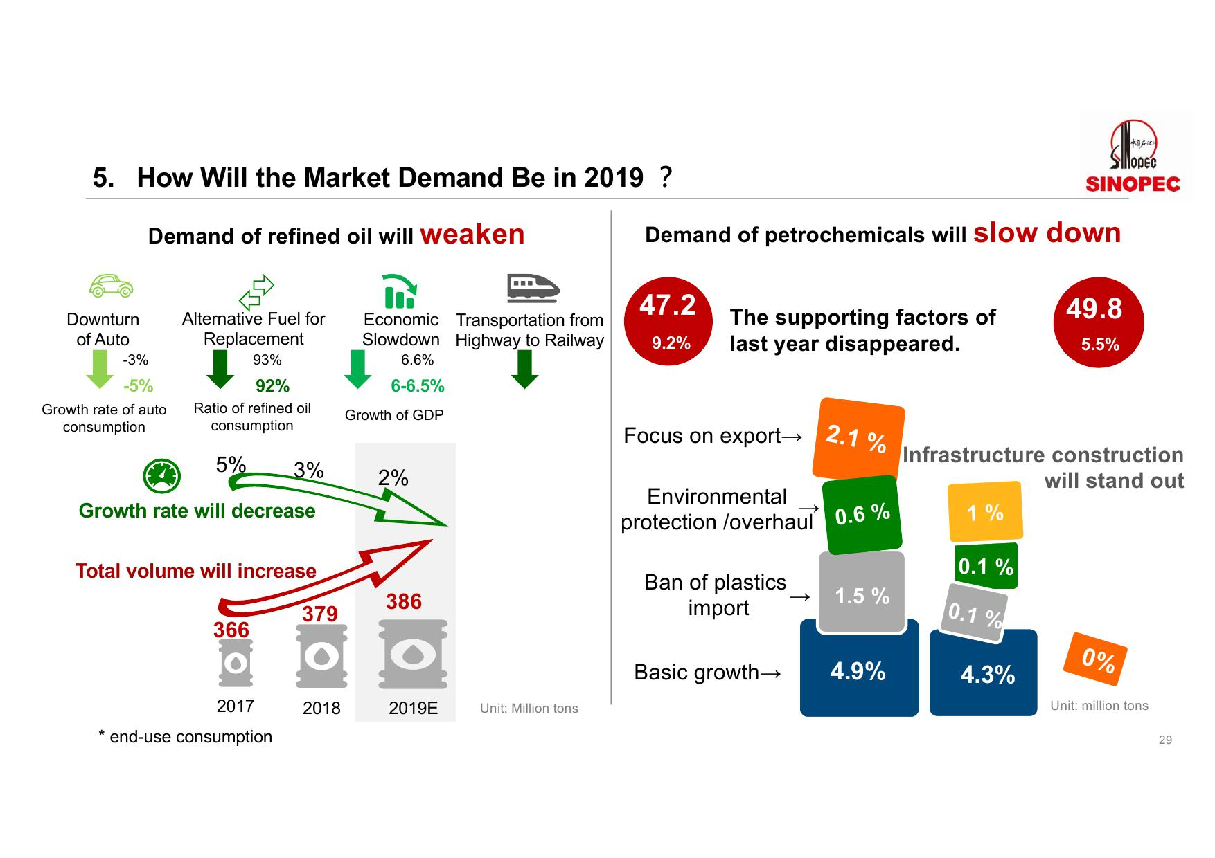](http://www.199it.com/wp-content/uploads/2019/04/2019%E4%B8%AD%E5%9B%BD%E8%83%BD%E6%BA%90%E5%8C%96%E5%B7%A5%E4%BA%A7%E4%B8%9A%E5%8F%91%E5%B1%95%E6%8A%A5%E5%91%8A4_000029.jpg)[](http://www.199it.com/wp-content/uploads/2019/04/2019%E4%B8%AD%E5%9B%BD%E8%83%BD%E6%BA%90%E5%8C%96%E5%B7%A5%E4%BA%A7%E4%B8%9A%E5%8F%91%E5%B1%95%E6%8A%A5%E5%91%8A4_000030.jpg)[](http://www.199it.com/wp-content/uploads/2019/04/2019%E4%B8%AD%E5%9B%BD%E8%83%BD%E6%BA%90%E5%8C%96%E5%B7%A5%E4%BA%A7%E4%B8%9A%E5%8F%91%E5%B1%95%E6%8A%A5%E5%91%8A4_000031.jpg)